**STA380 Time Series Analytics | Homework on Random Samples**

Submitted by: Ruchi Sharma [rs58898]

**Firm 01**

**Ques 01:** Test the data visually for conformity with the L specification of the Random Sample model. Explain clearly whether you think L applies and why (no hedging – you must indicate a definite yes or no.)

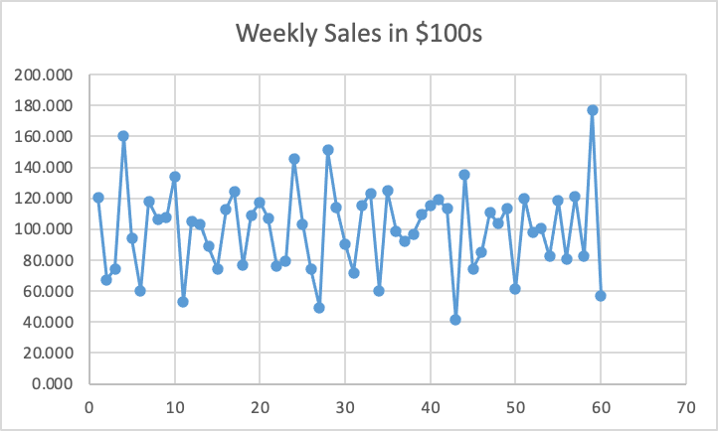

Yes, L applies.

By making a plot of the weekly

sales over time and examining

the general trend from early to

late, we can visualize that the

time series appears to be leveled.

The trend in means remains roughly

leveled indicating consistency with L

specification of the Random Sample

Model.

**Ques 02:** Test the data visually for conformity with the E specification of the Random Sample model. Explain clearly whether you think E applies and why (no hedging – you must indicate a definite yes or no.)



Yes, E applies.

By making a plot of the weekly

sales over time and examining

the general pattern of up-and-down

variation around the overall level from

early to late, we can visualize that the

time series is consistent with E.

The pattern of variation appears to be

roughly constant from start to end.

**Ques 03:** Test the data quantitatively for conformity with the “I” specification of the Random Sample model. Explain clearly whether you think “I” applies and why (no hedging –you must indicate a definite yes or no.)

No, I doesn’t apply.

Performing the Quantitative Test for I:

1. Take the lag(1) shifted sales.
2. Calculate lag(1) autocorrelation for doing a quantitive test by using CORREL(Series1, Series2) in Excel.

AutoCorr = -0.389

1. Check if AutoCorr is close to 0. If the value is close to zero then I is satisfied.
2. The calculation below shows that we reject the null hypothesis that AutoCorr is zero. Thus, I is NOT satisfied.

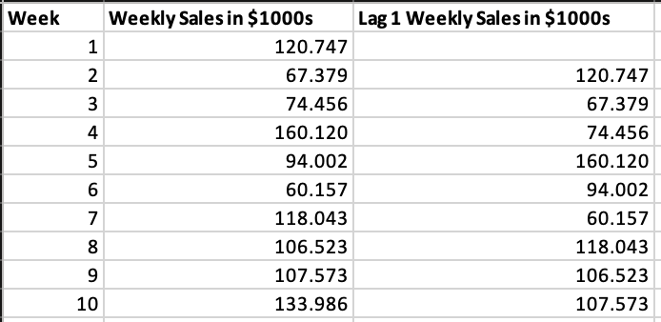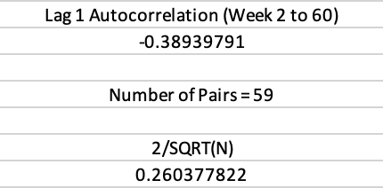

*… total 60 Weeks*

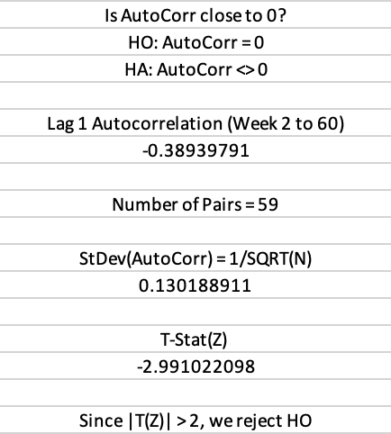

**Ques 04**: Suppose that the Random Sample model is valid for these data. In addition, suppose that weekly sales are normally distributed. Forecast sales for week 61 and give an interval in which you can have approximately 95% confidence that actual sales for week 61 will lie.

Assuming the Random Sample model is valid, the forecast for the Week 61 is going to be the Mean Value from Week 1 to Week 60. Thus, Forecasted Sales for Week 61 = $100034 with 95% confidence interval (44.840, 155.229) in $100s. 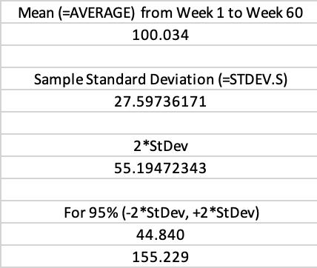

**Ques 05:** Suppose that the Random Sample model is valid for these data. In addition, suppose that weekly sales are normally distributed. Forecast sales for week 62 and give an interval in which you can have approximately 95% confidence that actual sales for week 62 will lie.

Assuming the Random Sample model is valid, the forecast for the Week 62 is going to be the Mean Value from Week 1 to Week 61. Thus, Forecasted Sales for Week 61 = $ 100034 with 95% confidence interval (45.301, 154.767) in $100s.

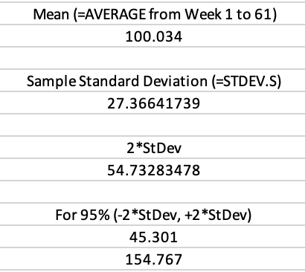

**Ques 06:** Suppose that the Random Sample model is valid for these data. Estimate mean sales per week and give an interval in which you can have approximately 95% confidence that the actual mean of the distribution of weekly sales will lie.

Mean sales = $ 100034, and 95% confidence interval = (93.051, 107.017) in $100s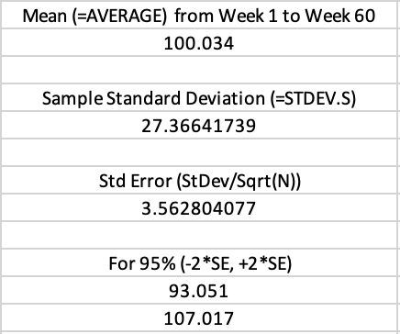

**Firm 02**

**Ques 07:** Regress weekly sales as Y on the week number as X. Test the residuals visually for conformity with the L specification of the Random Sample model. Explain clearly whether you think L applies and why (no hedging – you must indicate a definite yes or no.)

Regressing weekly sales as Y on the week number as X gives the following regression output: 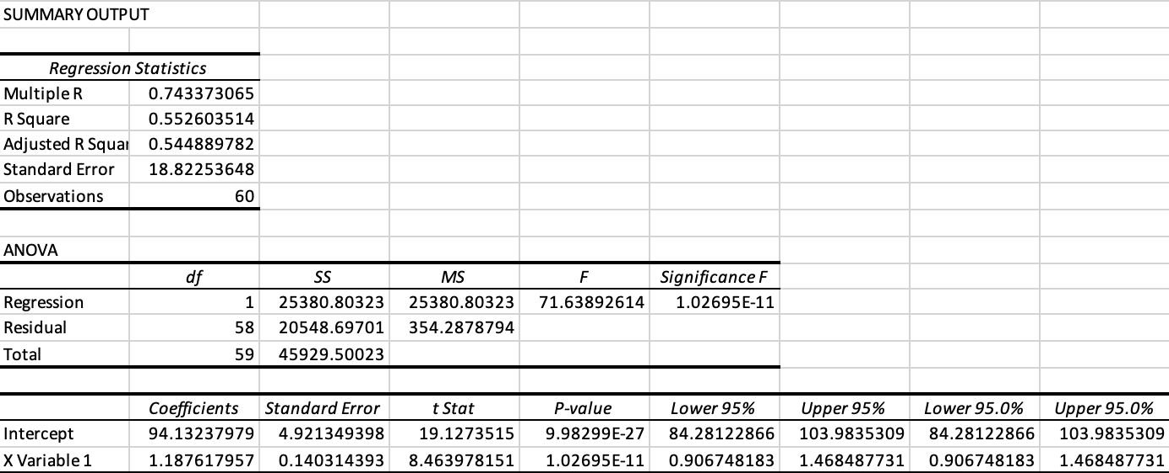

Calculating Residuals as Y_Actual - Y_Predicted 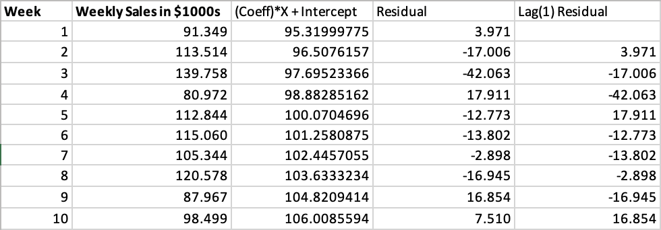

*… total 60 Weeks*

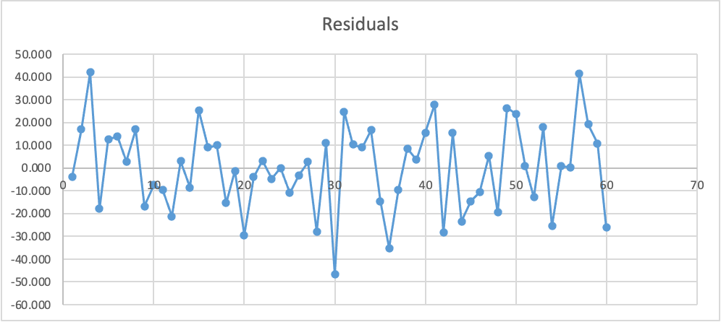

Yes, L applies.

By making a plot of the residuala over

time and examining the general trend

from early to late, we can visualize that

the time series appears to be leveled.

The trend in means remains roughly

leveled indicating consistency with L

specification of the Random Sample

Model.

**Ques 08:** Regress weekly sales as Y on the week number as X. Test the residuals visually for conformity with the E specification of the Random Sample model. Explain clearly whether you think E applies and why (no hedging – you must indicate a definite yes or no.)



Yes, E applies.

By making a plot of residuals over time

and examining the general pattern of

Up-and-down variation around the

overall level from early to late, we can

visualize that the time series is

consistent with E.

The pattern of variation appears to be

roughly constant from start to end.

**Ques 09:** Regress weekly sales as Y on the week number as X. Test the residuals quantitatively for conformity with the “I” specification of the Random Sample model. Explain clearly whether you think “I” applies and why (no hedging – you must indicate a definite yes or no.)

Yes, I applies.

Performing the Quantitative Test for I:

1. Take the lag(1) shifted sales.
2. Calculate lag(1) autocorrelation for doing a quantitive test by using CORREL(Series1, Series2) in Excel.

AutoCorr = -0.0761

1. Check if AutoCorr is close to 0. If the value is close to zero then I is satisfied.
2. The calculation below shows that we fail to reject the null hypothesis that AutoCorr is zero. Thus, I is satisfied. 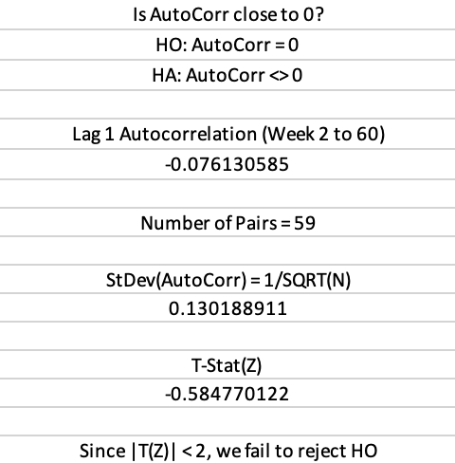

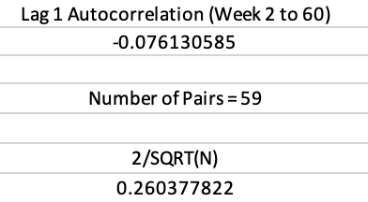

**Ques 10:** Suppose that Y1, Y2, Y3, … Yn is a Random Sample time series of non-degenerate random variables (i.e., the variance of each is positive [not zero]). Consider the time series of running totals of Y1, Y2, Y3, … Yn namely, Y1, Y1 + Y2, Y1 + Y2 + Y3, .... Is the time series of running totals …

(A) ... always a Random Sample?

(B) ... never a Random Sample?

(C) ... sometimes a Random Sample and sometimes not a Random Sample?

If your answer is (A) or (B), present a compelling argument for your position. Your argument need not be a mathematical proof – a clear intuitive argument will suffice. If your answer is (C), present an example of a Random Sample time series whose running totals are also a Random Sample, and a different example of a Random Sample whose running totals are not a Random Sample.

My answer is (B)

In the time series of running totals, the next point in time clearly depends on the previous point in time. Thus indicating the presence of autocorrelation which means the conditions of LIE will not be entirely satisfied. Thus, we can safely consider that it will never be a random sample.